**Backup Retention Check**

1. Login to the Azure Portal.
2. Check the Recovery Service Vault.
3. Check the Backup Policies [Retention time of backup].
4. Select Default Policy
5. Click on modify to check instant restore which mean Snapshot and vault

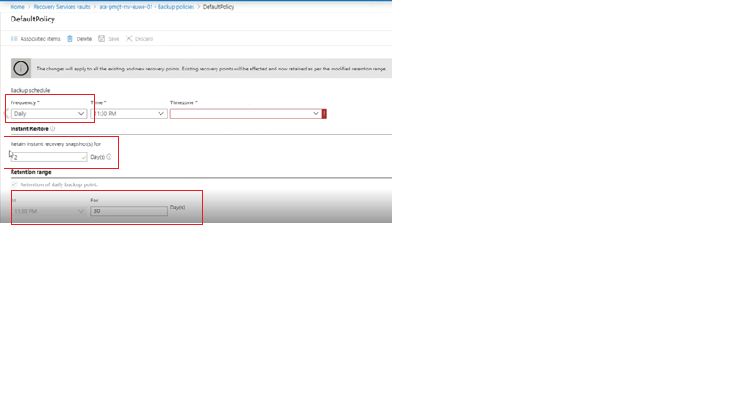

1. Retention of daily backup point: Retain backup taken every day for 30 Day(s)
2. Instant restore with Snapshot is 2 days
3. Validate one or two of the VMs to check if the configuration of the Backup policy matches with the VMs backup configuration [Check if the oldest backup is the same time as per the backup policy].